PAX Processor:

Assembler and FPGA User Manual

Last Edited 08/14/2008 by Michael S. Wang (msw2138@columbia.edu)

Table of Contents

Section 1: PAX Assembler

  - Installing and Editing the assembler

  - Using the assembler

Section 2: PAX FPGA

  - PAX-32
- Simulating PAX on ModelSim
- Running PAX on FPGA
- Loading PAX software onto FPGA

  - PAX-64
- Simulating PAX on ModelSim
- Running PAX on FPGA
- Loading PAX software onto FPGA

  - PAX-128: Current Status
Section 1: PAX Assembler

  - Installing and Editing the assembler

Currently, the PAX assembler is built under the “mozart” server at the PALMS website. All the source code and executable files of the PAX assembler are stored under the folder:

/home/mswang/CT-PAX/

Section 3 of the “PAX_ Assembler_Manual.doc” document describes the file structure and code structure of the CT-PAX folder, as well as how to edit and rebuild the PAX assembler.

To recompile the PAX assembler, use the script build_gnupax.sh under the CT-PAX folder.
  - Using the assembler

All the files necessary to use the PAX assembler are stored on the “mozart” server under the folder:

/home/mswang/PAX_Assembler/

To simply use the assembler, the files within this folder is enough. To edit or recompile the assembler, one must see the CT-PAX folder as described in section 1.2.

The PAX processor comes in three different sizes: PAX-32, PAX-64, and PAX-128. There are three corresponding PAX assemblers. The PAX_Assembler folder is organized into 5 subfolders:
- ../bin_32
- ../bin_64
- ../bin_128
- ../scripts
- ../test_programs

../bin_32
The ../bin_32/ folder contains the binary executables for the PAX-32 assembler. These executables are copied from a folder under the CT-PAX/ folder after the assembler is recompiled for the PAX-32 processor:
/home/mswang/CT-PAX/crosstool/gcc-4.1.0-glibc-2.3.2/arm-unknown-linux-gnu/bin

../bin_64
The ../bin_64/ folder contains the binary executables for the PAX-64 assembler. These executables are copied from a folder under the CT-PAX/ folder after the assembler is recompiled for the PAX-64 processor:
/home/mswang/CT-PAX/crosstool/gcc-4.1.0-glibc-2.3.2/arm-unknown-linux-gnu/bin

../bin_128
The ../bin_128/ folder contains the binary executables for the PAX-128 assembler. These executables are copied from a folder under the CT-PAX/ folder after the assembler is recompiled for the PAX-128 processor:
/home/mswang/CT-PAX/crosstool/gcc-4.1.0-glibc-2.3.2/arm-unknown-linux-gnu/bin

../scripts
The ../scripts/ folder contains three different scripts for running the PAX assembler, one for each of the three different PAX sizes. The inputs for the PAX scripts are as follows:

sh pax_s2o_32.sh [name of pax-32 assembler file stored in the test_programs folder]
sh pax_s2o_64.sh [name of pax-64 assembler file stored in the test_programs folder]
sh pax_s2o_128.sh [name of pax-128 assembler file stored in the test_programs folder]

examples:

sh pax_s2o_32.sh pax32_AES_Encryption
sh pax_s2o_64.sh pax64_AES_Encryption
sh pax_s2o_128.sh pax128_AES_Encryption

The output of the assembler is a .mif file, which contains the 32-bit machine code necessary to feed into the PAX FPGA.

../test_programs
The ../test_programs/ folder contains the PAX .s files are to be run by the PAX assembler. Currently, the scripts in the ../scripts folder obtains files from this ../test_programs/ folder to run on the PAX assembler. More .s files can be added to this folder for more testing and use of the PAX assembler.

Section 2: PAX FPGA

  - PAX-32

Simulating PAX-32 on ModelSim
- Open the ../pax32_ModelSim/ folder.
- Copy the .mif file (containing the machine code for PAX-32) created by the PAX assembler (See section 1) to this folder.
- Rename this .mif file as instruction_memory_xilinx.mif. Delete or rename the instruction_memory_xilinx.mif file that was previously in folder.
- Open up the pax32_ModelSim.mpf program, which opens up ModelSim and loads the PAX-32 project. A screenshot of the ModelSim window is:

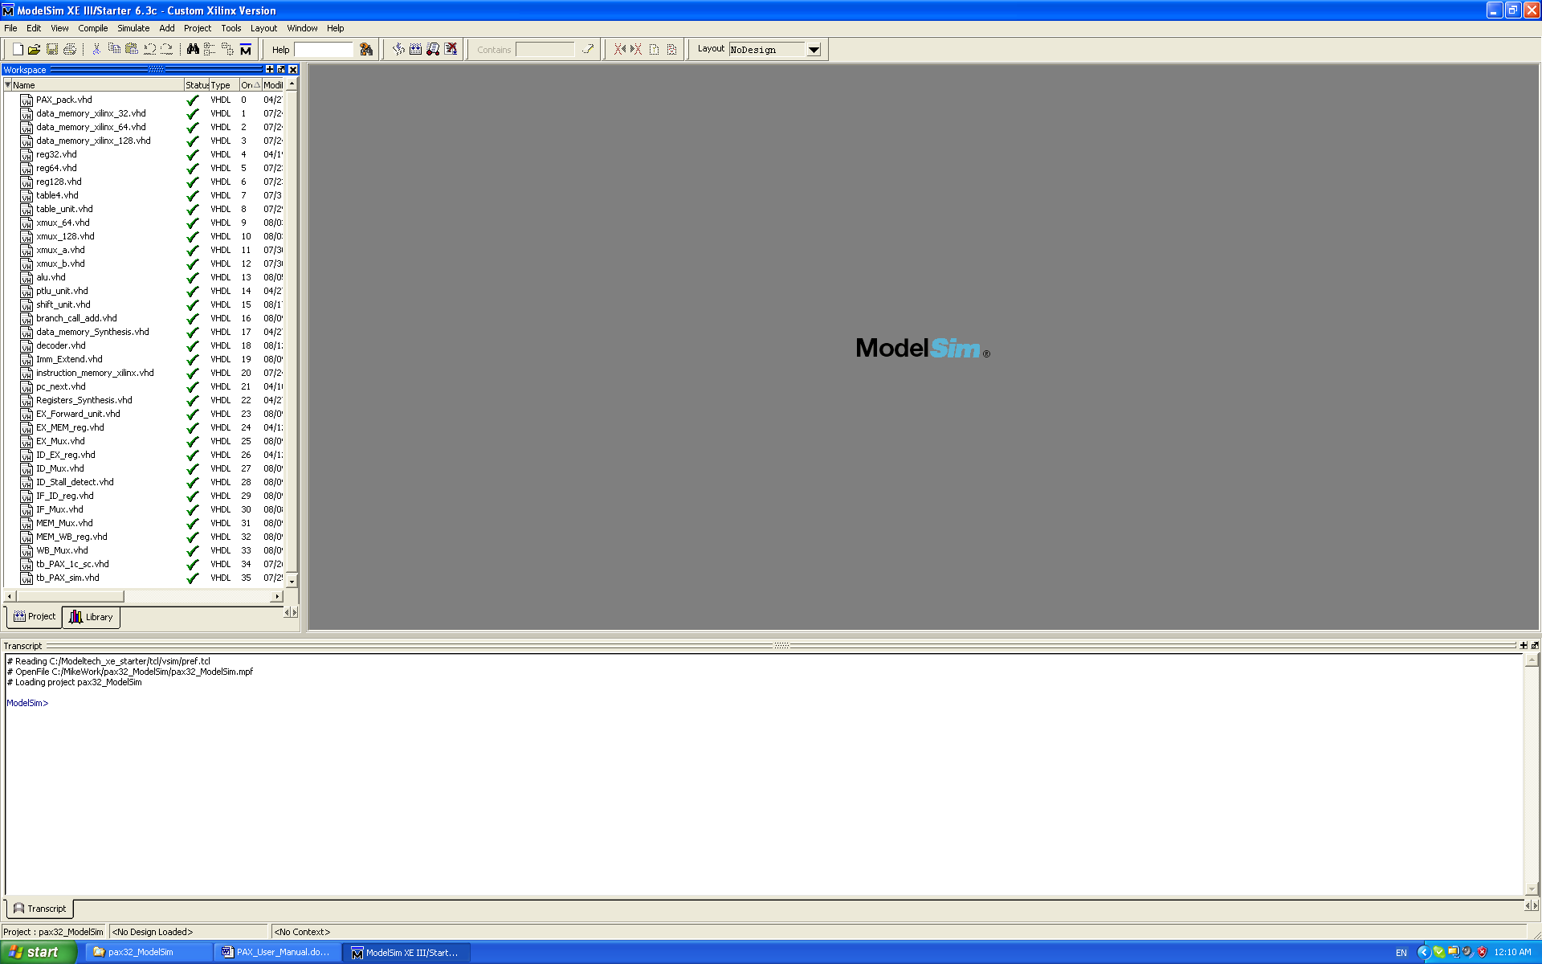

- Click on “compile tab”, and select “compile all”. (Although this step is not necessary unless any files within the workspace has changed, it is nice to run through it the first time).

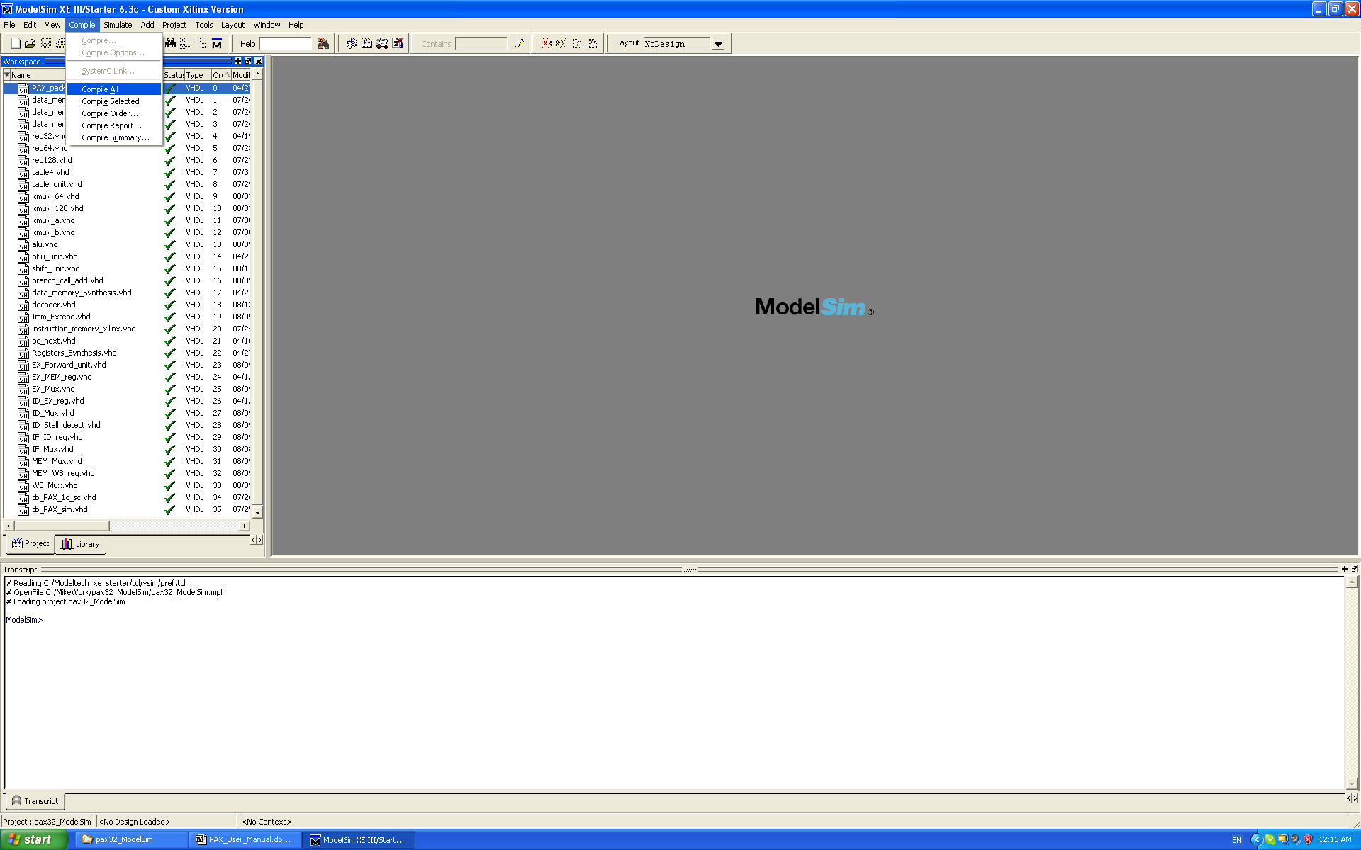

- In the workspace window, select the Library tab. Under work directory, select the tb_pax_sim entity. Double-click it to start ModelSim simulation of PAX-32 with the loaded PAX-32 program as specified from the .mif file from step 2.

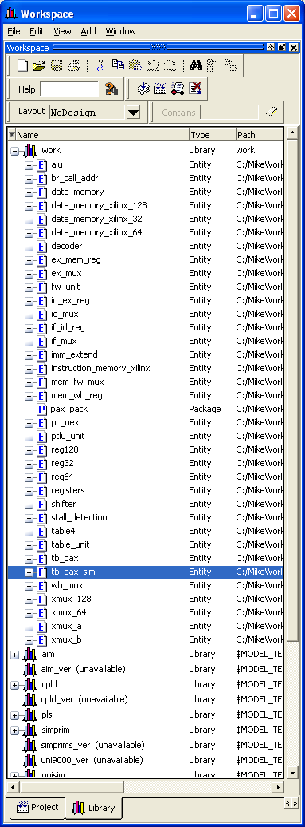

- Click on the View tab and click on the Wave option.

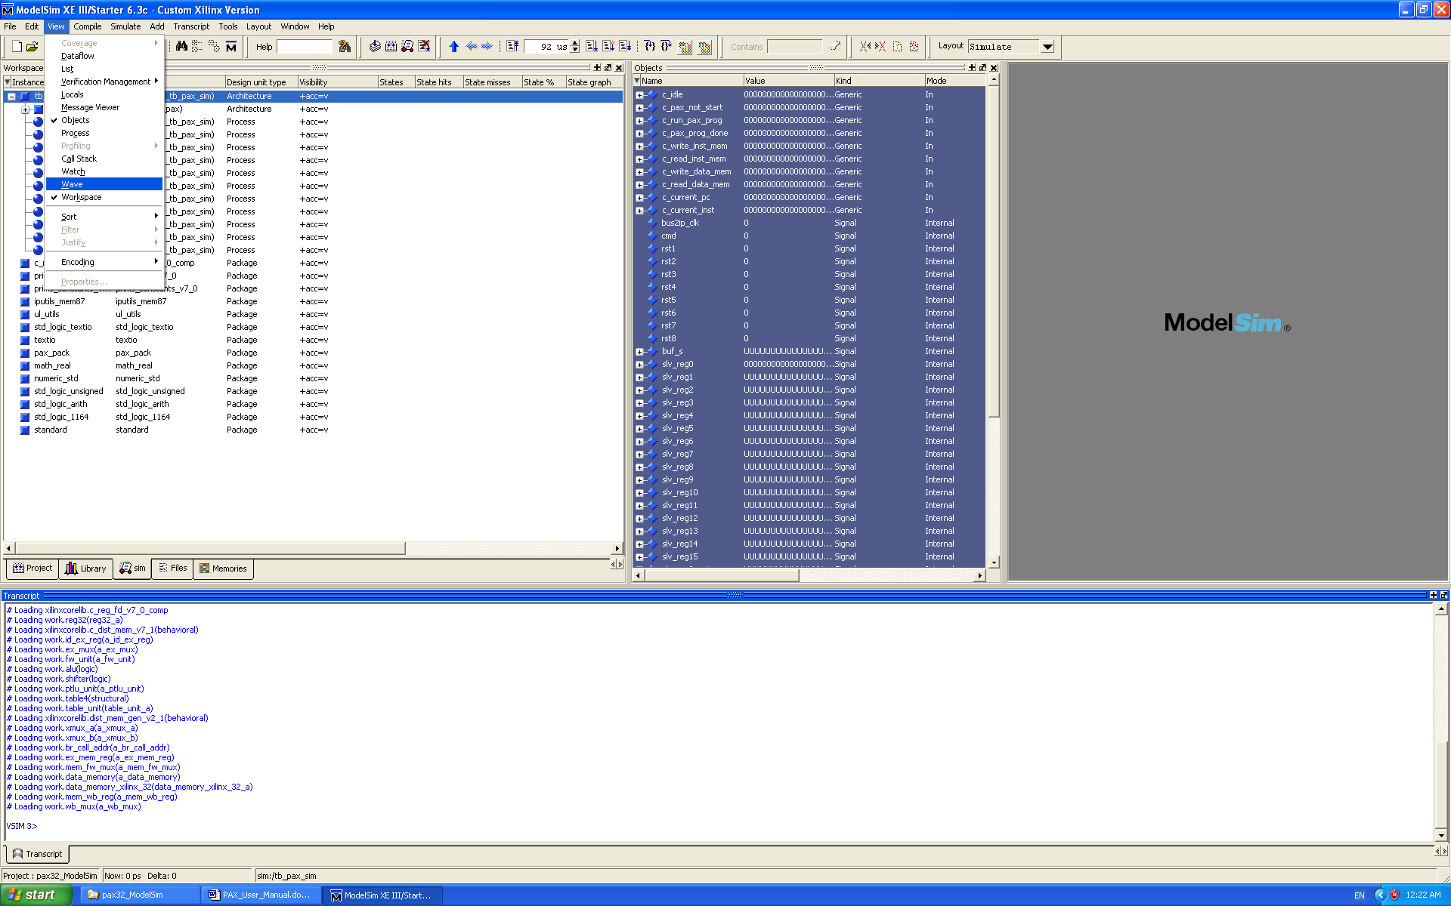

- This opens up the Wave window. Undock it for a larger view.

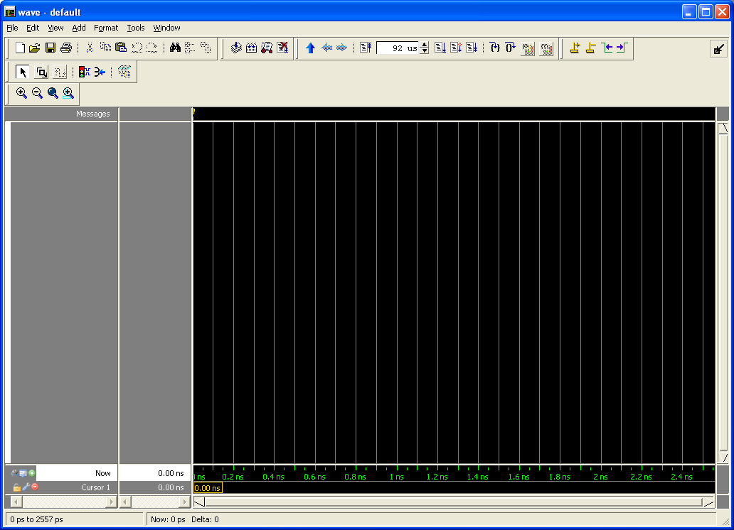

- Click on File -> load and open the wave.do file. This contains a preset group of settings for the ModelSim simulation of PAX-32. Click on “run” button on the top toolbar to allow ModelSim to simulate for the specified 92 us.

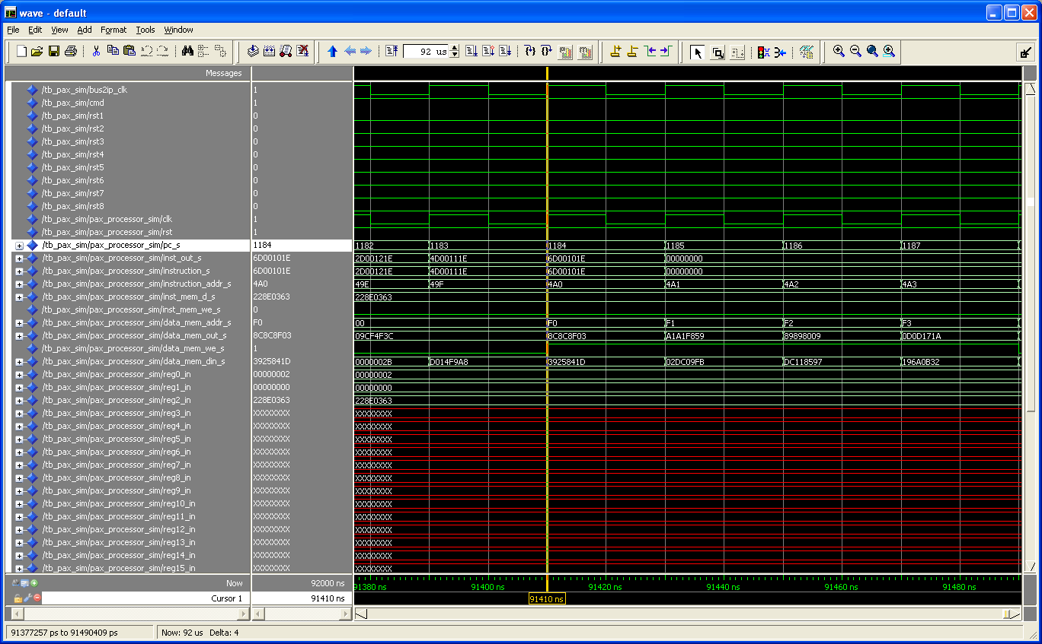

- Look at the waves to confirm that the simulation results are correct. As an example, assume that the .mif file that we loaded was pax32_AES_Encryption.mif. Open up the pax32_AES_Encryption.s file and confirm that the last four instruction writes the following results to data memory at the corresponding PC value:

PC | Data Memory Address | Data Memory Data
1184 | 0xf0 | 0x3925841d
1185 | 0xf1 | 0x02dc09fb
1186 | 0xf2 | 0xdc118597
1187 | 0xf3 | 0x196a0b32

Confirm this result on ModelSim.

Running PAX-32 on FPGA
- Open the ../pax32_fpga/ folder
- Open the pax32_fgpa.xmp program, which opens up the Xilinx FPGA software and opens the PAX-32 FGPA project. A screenshot is shown below:

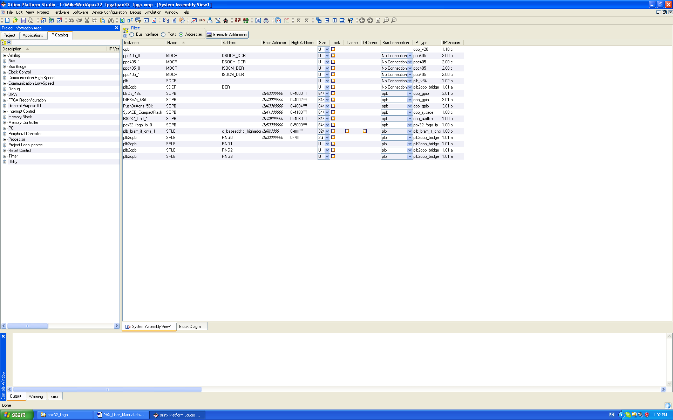
- Connect the FGPA to the computer.
- Open up a Hyperterminal connection, and change the settings as shown below:

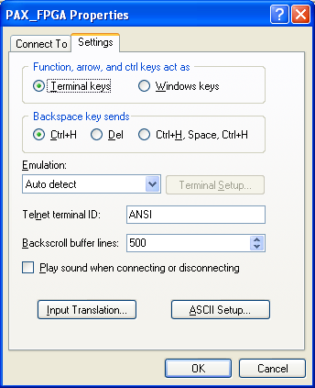
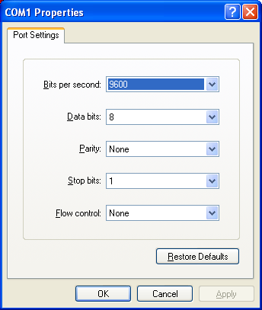
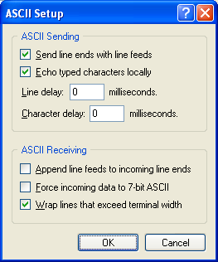

- Initially, the PAX-32 project has an AES-128 encryption program loaded. To run this program on the FPGA, click on Device Configuration -> Download Bitstream. The program should run on the FPGA and printout the following results on the Hyperterminal screen:

-- Entering main() --

Running SysAceSelfTestExample() for SysACE_CompactFlash...
SysAceSelfTestExample FAILED

Running GpioOutputExample() for LEDs_4Bit...
GpioOutputExample PASSED.

Running GpioInputExample() for DIPSWs_4Bit...
GpioInputExample PASSED. Read data:0xF

Running GpioInputExample() for PushButtons_5Bit...
GpioInputExample PASSED. Read data:0x1F

***** PAX-32 Processor on Virtex-II Pro FPGA *****

------ Last Edited 08/08/08 by Michael Wang ------

- pax32: CMD reset to: 0x0

------ Test PAX-32 Instruction Memory ------

- pax32: write inst mem at 0x00A0, dat= 0x22222222

- pax32: write inst mem at 0x00A1, dat= 0x66666666

- pax32: read inst mem at 0x00A0, dat= 0x22222222

- pax32: read inst mem at 0x00A1, dat= 0x66666666

------ Test PAX-32 Data Memory ------

- pax32: write data mem at 0x00F0, dat= 0x11111111

- pax32: write data mem at 0x00F1, dat= 0x55555555

- pax32: read data mem at 0x00F0, dat= 0x11111111

- pax32: read data mem at 0x00F1, dat= 0x55555555

------ Load and Run PAX-32 Program from program.pax ------

- pax32: loading program to inst memory. prog size=1185...done.

- pax32: start to run program...

- pax32: program execution is done

- pax32: User stopped pax

------ Program Descriptions (change for different program.pax) ------

function : AES-128 Encryption

input : 0x 3243f6a8 885a308d 313198a2 e0370734

key : 0x 2b7e1516 28aed2a6 abf71588 09cf4f3c

expected output : 0x 3925841d 02dc09fb dc118597 196a0b32

PAX FPGA output : 0x 3925841D 02DC09FB DC118597 196A0B32

***** PAX-32 Program Completed *****

-- Exiting main() --

- To capture the printout of the Hyperterminal screen onto a text file, click on Transfer -> Capture Text on the Hyperterminal window.

- Confirm that the Hyperterminal output matches with the one above.

Loading PAX software onto FPGA

Above, we looked at how to run a pre-loaded AES-128 encryption program on the PAX-32 FPGA. Next, we look at how to dynamically load new programs to run on the FPGA:

- Write a different program using PAX-32 assembly language
- Assemble the program using the PAX-32 assembler as described in Section 1. This turns the .s file into a .mif file, which contains the PAX-32 machine code of the program
- Convert the .mif file into a program.pax file, which contains a C array that stores the machine code of the program. This array of PAX machine code is loaded by the PowerPC processor on the FPGA onto the PAX-32 instruction memory. This mif to program.pax conversion is performed by the MifConv program found in the folder:

/home/mswang/MifConf

This program takes as input:

./MifConv [mif file]

And outputs a program.pax file.

- Copy this program.pax file into the folder under the PAX-32 FPGA directory:

../pax32_fpga/SDK_projects/TestApp_Peripheral/

- Reopen the pax32_fgpa.xmp project
- Under the Xilinx window, click on Software -> Launch Platform Studio SDK
A screenshot is shown below:

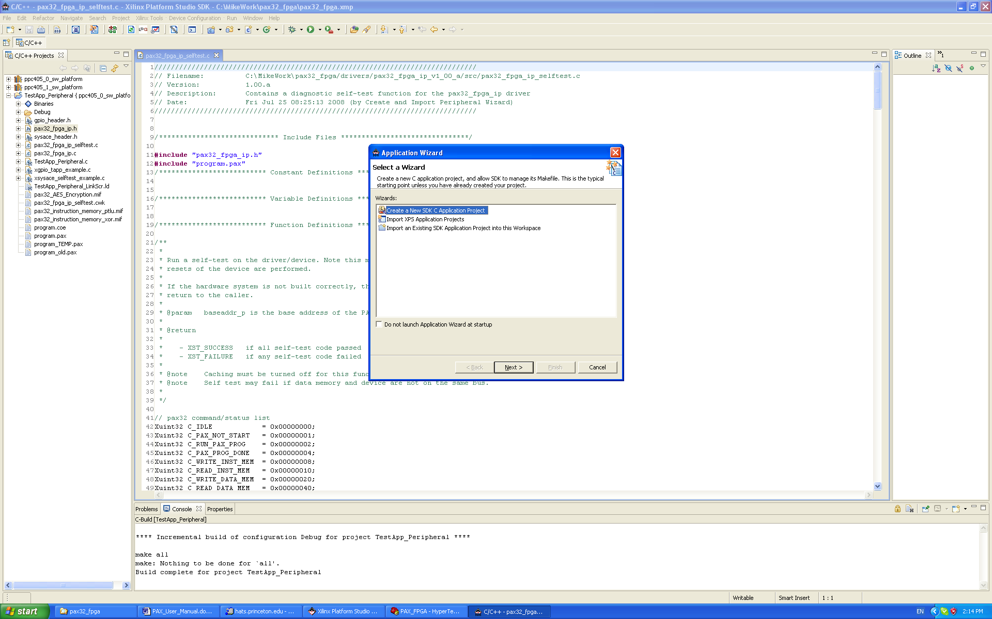

- “Cancel” the Application Wizard window because the SDK environment has already been setup for the current PAX-32 FPGA project.
- Change the pax32_fpga_ip_selftest.c program so that it outputs results to the Hyperterminal screen that makes sense for the current program stored in program.pax. More specifically, make changes to the part of the pax32_fpga_ip_selftest.c program:

xil_printf("------ Program Descriptions (change for differnt program.pax) ------\n\r");
xil_printf("function : AES-128 Encryption \n\r");
xil_printf("input : 0x 3243f6a8 885a308d 313198a2 e0370734 \n\r");
xil_printf("key : 0x 2b7e1516 28aed2a6 abf71588 09cf4f3c \n\r");
xil_printf("expected output : 0x 3925841d 02dc09fb dc118597 196a0b32 \n\r");
xil_printf("PAX FPGA output : 0x %08x %08x %08x %08x \n\r", f0, f1, f2, f3);

- Recompile the pax32_fpga_ip_selftest.c program using the SDK environment. This allows the newly changed program.pax file to be compiled.
- Make sure that the FPGA is turned on, and the Hyperterminal screen is connected.
- Go back to the Xilinx Platform Studio window. Click on Device Configuration -> Update Bitstream.
- Click on Device Configuration -> Download Bitstream.
- View the results on Hyperterminal and confirm that it is the desired result.

  - PAX-64

Simulating PAX on ModelSim

- This is the same as for PAX-32, except all the files are stored in the folder:

../pax64_ModelSim/

- ModelSim can simulate any .mif file that is loaded onto the PAX-64 instruction memory. As an example, assume that the .mif file that we loaded was pax64_AES_Encryption.mif. Open up the pax32_AES_Encryption.s file and confirm that the last two instruction writes the following results to data memory at the corresponding PC values:

PC | Data Memory Address | Data Memory Data
1022 | 0xf0 | 0x 3925841d 02dc09fb
1023 | 0xf1 | 0x dc118597 196a0b32

Confirm this result on ModelSim.

Running PAX on FPGA

This is the same as for PAX-32, except all the files are stored in the folder:

../pax64_fpga/

Loading PAX software onto FPGA

This is the same as for PAX-32, except all the files are stored in the folder:

../pax64_fpga/

  - PAX-128: Current Status

Currently, the PAX-128 VHDL works on Modelsim. ModelSim can simulate any .mif file that is loaded onto the PAX-128 instruction memory. As an example, assume that the .mif file that we loaded was pax128_AES_Encryption.mif. Open up the pax128_AES_Encryption.s file and confirm that the last instruction writes the following results to data memory at the corresponding PC value:

PC | Data Memory Address | Data Memory Data
926 | 0xf0 | 0x 3925841d 02dc09fb dc118597 196a0b32

Confirm this result on ModelSim.

PAX-128 does not yet work on the FPGA. We are not currently using block memory to generate the instruction and data memory. Instead, all memory are generated using the LUTs. For PAX-128, the FPGA is no longer large enough to support it. For future work, I suggest using block memory to generate the PAX memory, which can significantly reduce the amount of LUTs used, and thus, may allow PAX-128 to fit on the FPGA.

